BEEE EVALUATION

**Circuit Diagram**:

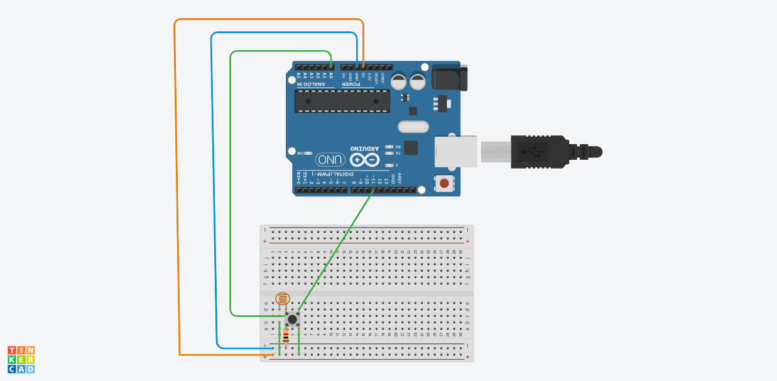

**Theory:**

Concepts Used:

1.Coding Arduino.

2.Working with breadboard.

3.working with LDR.

**Learning & Observations**:

Learned the use of breadboard.Understood the use of LDR. Understood the working of Arduino.

There are many uses of Arduino in electronic field . We can make many useful devices like drones using Arduino.

**Problems & Troubleshooting**

There was some problem with LDR,solved it.

**Precautions**

1. Declare pins used .
2. Connect LDR properly
3. Connect switch properly

**Learning Outcomes**

Learned Arduino coding and it was really fun.Understood the uses of Arduino . Things I learned will be very useful.

Learned the use of LDR.

CODE

double Light (int RawADC0)

{

double Vout=RawADC0*0.0048828125;

int lux=(2500/Vout-500)/10;

return lux;

}

void setup() {

Serial.begin(9600);

}

void loop() {

Serial.print("Light Intensity:");

Serial.print(int(Light(analogRead(0))));

Serial.println(" Lux");

delay(1000);

}